|  |  |
| --- | --- |
| linear IPS | Year 12 Specialist  TEST 4  Weds 28 Aug 2019  TIME: 50 minutes working  Classpads allowed  No notes allowed  45 marks 8 Questions |

Name:_______________________________

Teacher: ____________________________

**Note: All part questions worth more than 2 marks require working to obtain full marks.**

Q1 ( 3, 3 & 3 = 9 marks)

Determine the following integrals using the given substitutions.

1. 

|  |
| --- |
| **Solution** |
|  |
| **Specific behaviours** |
| 🗸 subs du  🗸 integrates wrt u  🗸 expresses answer in terms of x only with a constant |

1. 

|  |
| --- |
| **Solution** |
|  |
| **Specific behaviours** |
| 🗸 subs du  🗸 integrates wrt u  🗸 expresses answer in terms of x only (no need for constant) |

1. 

|  |
| --- |
| **Solution** |
|  |
| **Specific behaviours** |
| 🗸 subs du  🗸 integrates wrt u  🗸 expresses answer in terms of x only (no need for constant) |

Q2 (3 marks)

Identical twins Sherry and Mary were both given the following integral to solve. 

Sherry’s solution was as follows.



While Mary’s solution was to:



Explain why the solutions differ and state which is the correct answer. Show your reasoning.

|  |
| --- |
| **Solution** |
| Both missing constants  Constant differ  Both answers correct as |
| **Specific behaviours** |
| 🗸 mentions that constants missing  🗸 states that constants are different  🗸 shows that both expressions differ by an added constant |

Q3 (3 & 4 = 7 marks)

Determine the following integrals showing all working.

1. 

|  |
| --- |
| **Solution** |
|  |
| **Specific behaviours** |
| 🗸 integrates using ln  🗸 uses absolute value  🗸 determines result |

Q3 cont-

1.  (4 marks)

|  |
| --- |
| **Solution** |
|  |
| **Specific behaviours** |
| 🗸 uses correct partial fractions with 4 constants  🗸 solves for at least one constant  🗸 sets up simultaneous equations for other constants  🗸 integrates correctly (no need to add c) |

Q4 (5 marks)

The shaded region is rotated about the y axis. Determine the volume of the resulting solid.

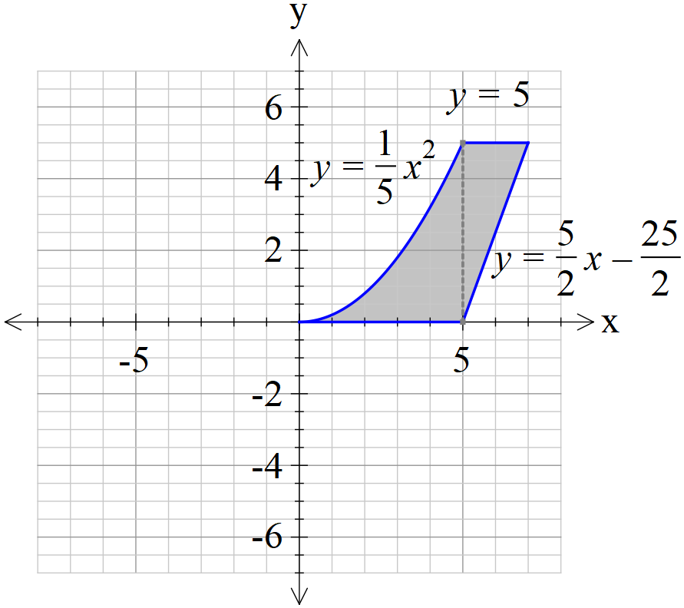

|  |
| --- |
| **Solution** |
|  |
| **Specific behaviours** |
| 🗸 uses correct integral around y axis  🗸 uses correct limits  🗸 sets up a difference calculation with volumes  🗸 states correct approx. volume |

Q5 (1 & 4 = 5 marks)

The mass,  grams, of a gas produced in a factory at time  seconds can be modelled by the logistical formula  with an initial mass of 0.1 grams.

1. Determine the limiting mass as .

|  |
| --- |
| **Solution** |
|  |
| **Specific behaviours** |
| 🗸 states limiting value |

1. Show that  and determine the constant.

|  |
| --- |
| **Solution** |
|  |
| **Specific behaviours** |
| 🗸 separates variables  🗸 sets up partial fractions  🗸 integrates and shows why absolute value not needed  🗸 solves for constant |

Q6 (3 & 3 = 6 marks)

1. Sketch the slope field for  on the axes below.

|  |
| --- |
| **Solution** |
|  |
| **Specific behaviours** |
| 🗸 shows one zero  🗸 shows both zeros  🗸 pattern agrees with above |

1. Given that point A (-1,1) is a known point on our solution, show this curve on the slope field above and give the equation.

|  |
| --- |
| **Solution** |
|  |
| **Specific behaviours** |
| 🗸 shows curve on slope field going through pt A  🗸 integrates slope field  🗸 solves for constant |

Q7 (2, 3 & 2 = 7 marks)

A particle with displacement, metres from the origin at time  seconds, moves such that .

1. Show that the motion is simple harmonic.

|  |
| --- |
| **Solution** |
|  |
| **Specific behaviours** |
| 🗸 obtains acceleration function  🗸 shows correct differential equation for SHM |

1. Determine the first two times that the speed is exactly half of the maximum speed.

|  |
| --- |
| **Solution** |
| t=0 v=5m/s  v  First two times are |
| **Specific behaviours** |
| 🗸 states initial time  🗸 uses negative velocity for second time  🗸 solves for second time, approx |

1. Determine the distance travelled in the first 3 seconds.

|  |
| --- |
| **Solution** |
|  |
| **Specific behaviours** |
| 🗸 uses correct integral with absolute velocity  🗸 states distance travelled |

Q8 (4 marks)

A particle with displacement, metres from the origin at time  seconds, has an acceleration given by . The amplitude of the motion is given by  metres.

Show by using integration that the speed,  metres per second, is given by .

|  |
| --- |
| **Solution** |
|  |
| **Specific behaviours** |
| 🗸 uses alternative expression for accleration  🗸 uses separation of variables  🗸 integrates correctly  🗸 solves for constant in terms of A & n |